**TITLE: Creating a sponsored post for Instagram**

**Project: Hunger mania shop**

TEAM ID: 7180888AB5ED265930141358429885E4

MEMBER 1: MAHADEVI T([A17D49D63D86565BE654D2154AB88848](https://naanmudhalvan.tn.gov.in/reports/dashboard/student/detail/A17D49D63D86565BE654D2154AB88848/))

MEMBER 2: VIJAYA PRIYA V([5BECEA191974B81B9AA4720FA4339067](https://naanmudhalvan.tn.gov.in/reports/dashboard/student/detail/5BECEA191974B81B9AA4720FA4339067/))

MEMBER 3: LAVANYA S([4BD268C4D8508CEB3C349228E5425A52](https://naanmudhalvan.tn.gov.in/reports/dashboard/student/detail/4BD268C4D8508CEB3C349228E5425A52/))

MEMBER 4: SANDHIYA V([7180888AB5ED265930141358429885E4](https://naanmudhalvan.tn.gov.in/reports/dashboard/student/detail/7180888AB5ED265930141358429885E4/))

MEMBER 5: SUSHMITHA S([A34B49AE5E4AE87B9C44532270157DDF](https://naanmudhalvan.tn.gov.in/reports/dashboard/student/detail/A34B49AE5E4AE87B9C44532270157DDF/))

Gmail: hungermania02@gmail.com

**OUR PROJECT IS robust and maintainable IN THE ASPECTS OF:**

**1. Debugging:**

* **Interactive Debugging Tools:** Implement and make use of interactive debugging tools and environments. These tools allow you to set breakpoints, inspect variables, and step through your code to identify and fix issues efficiently.
* **Logging:** Incorporate a comprehensive logging system in your project to record important events and error messages. Logging helps in tracking the execution flow and identifying the root cause of issues.
* **Error Handling:** Implement proper error handling mechanisms to gracefully handle exceptions and unexpected situations. Include informative error messages to aid in troubleshooting.
* **Unit Testing:** Develop unit tests to verify the correctness of individual components and functions in your project. Automated testing frameworks can help catch bugs early and ensure code reliability.
* **Integration Testing:** Perform integration testing to check how different parts of your project work together. This helps identify issues that may arise from the interaction between components.
* **Code Review:** Conduct code reviews with team members to have fresh eyes on your codebase. Code reviews often uncover bugs, improve code quality, and promote best practices.
* 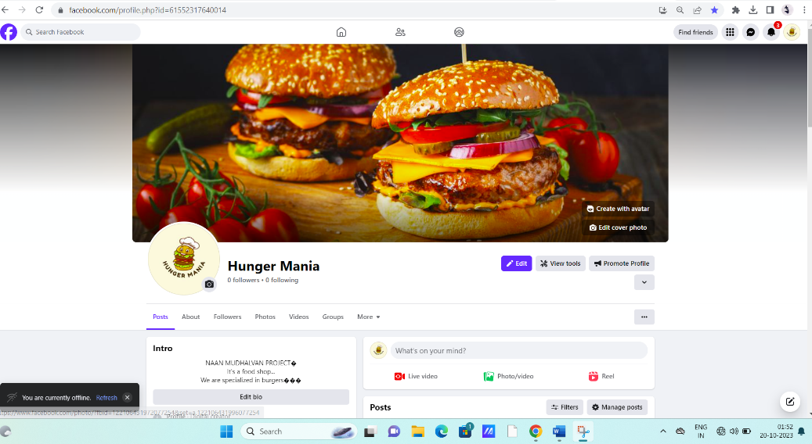

**2. Traceability:**

* **Version Control:** Use a version control system (e.g., Git) to track changes and maintain a history of your project. Commits, branches, and tags provide traceability and allow you to roll back to previous states if necessary.
* **Documentation:** Create documentation that describes the project's architecture, design, and functionality. Include detailed explanations of how different components interact. This documentation serves as a reference for developers and enhances traceability.
* **Issue Tracking:** Employ issue tracking systems (e.g., Jira, Trello, or GitHub Issues) to log and manage bugs, feature requests, and tasks. Link issues to code changes for traceability.
* **Change Logs:** Maintain a change log that records all modifications, additions, and deletions in your codebase. This provides a clear history of changes and their reasons.
* **Requirements Traceability:** Ensure that your project's requirements are well-documented and linked to specific code changes. This helps in confirming that the project aligns with its initial objectives.
* **Dependency Management:** Keep a record of external dependencies and libraries used in your project. Use package managers to document and manage these dependencies effectively.
* **Continuous Integration/Continuous Deployment (CI/CD):** Implement CI/CD pipelines to automate builds, testing, and deployment. CI/CD pipelines enhance traceability by associating specific code versions with deployment states.
* **Auditing:** Periodically review and audit your project's codebase, documentation, and dependencies to ensure that traceability is maintained over time.